Title of ExtendedAbstract

**Thomas Koshizuka1**\***, Jennifer Huerta2, and Hanako Sasaki3**

1* Affiliation, Postal Address, E-mail address

2 Affiliation, Postal Address, E-mail address

3 Affiliation, Postal Address, E-mail address

Key Words: *Authors must write about 5 keywords here.*

**1 Introduction**

Authors are invited to submit electronically Extended Abstract through the web site before **October 24, 2022.** Authors must prepare Extended Abstract, with using this template. Its length should be no shorter than **3 pages**, including key figures and references.

Extended Abstract must be written in English, following this template. Single column format must be used.

It must contain the full name, affiliation, postal address, and e-mail address of the authors. In the case of joint authorships, the name of the author who will actually present the paper at the workshop should be indicated with an asterisk (i.e. *).

The file must be converted to Portable Document Format (PDF) before submission through the web site. Other formats are not accepted.

**2 Subsection and Sub-subsection**

Extended Abstract can be divided in as many sections as you decide. The numbering of subsection and sub-subsection should follow the below examples.

**2.1 Subsection Title Example**

**2.1.1 Sub-subsection Title Example**

**3 Equations**

Equations should be included directly in your Extended Abstract. They must be numbered consecuitively and centered on the page width.

(1)

$\frac{∂ρ}{∂t}+\frac{∂ρu}{∂x}+\frac{∂ρυ}{∂y}+\frac{∂ρw}{∂z}=0$

**4 Figures and Tables**

Figures and Tables can be included directly in your Extended Abstract. All figures and Tables must be numbered consecutively and centered on the page width.

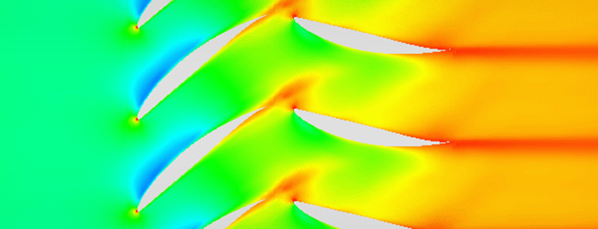

Figure 1 Schematic of Rotor/Stator Interaction.

**5 Conclusion and Future Work**

AJWTF2022 will be held in the beautiful city of Utsunomiya, Japan. All organizing committee members look forward to welcoming you all to what we hope will be a memorable event.

For any question, please contact the AJWTF2022 Secretariat.

E-mail: ajwtf2022@rs.tus.ac.jp

**References**

1. Messinger, B.L., Equilibrium Temperature of an Unheated Icing Surface as a Function of Air Speed, *Journal of Aerospace Science* 20 (1953) 29–42.
2. Suzuki, T. et al., Proposal of Hematocrit-Based Non-Newtonian Viscosity Model and its Significance in Intracranial Aneurysm Blood Flow Simulation, *Journal of Non-Newtonian Fluid Mechanics* 290 (2021) 1–11.